**Assignment 18 -16-Apr**

Problem Statement 1:

Is gender independent of education level? A random sample of 395 people were surveyed

and each person was asked to report the highest education level they obtained. The data that

resulted from the survey is summarized in the following table:

High School Bachelors Masters Ph.d. Total

Female 60 54 46 41 201  
Male 40 44 53 57 194  
Total 100 98 99 98 395

Question: Are gender and education level dependent at 5% level of significance? In other

words, given the data collected above, is there a relationship between the gender of an

individual and the level of education that they have obtained?

## Solution

## H0: Gender and education independent

## H1: Gender and education dependent

## The Expected frequency under the null hypothesis is given

E = row total * column total / sample size

Row totals and column totals are given above sample size = 395

Therefore, we have expected frequencies as follows:

High School Bachelors Masters Ph.d.  
Female 50.886 49.868 50.377 49.868   
Male 49.114 48.132 48.623 48.132

Therefore, Χ2 = 1.632 + 0.342 + 0.38 + 1.577 + 1.691 + 0.355 + 0.394 + 1.634 = 8.006

Χ20.95  for degrees of freedom 3 = 7.815.

Since 8.006 > 7.815, we reject the null hypothesis. Therefore, gender and education are dependent

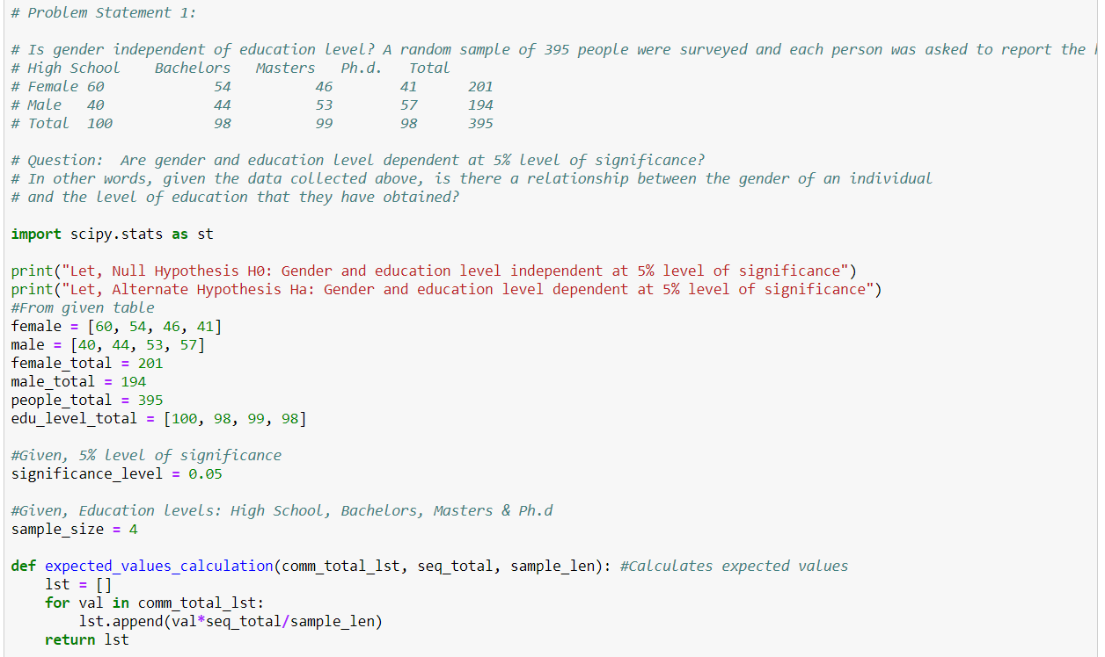

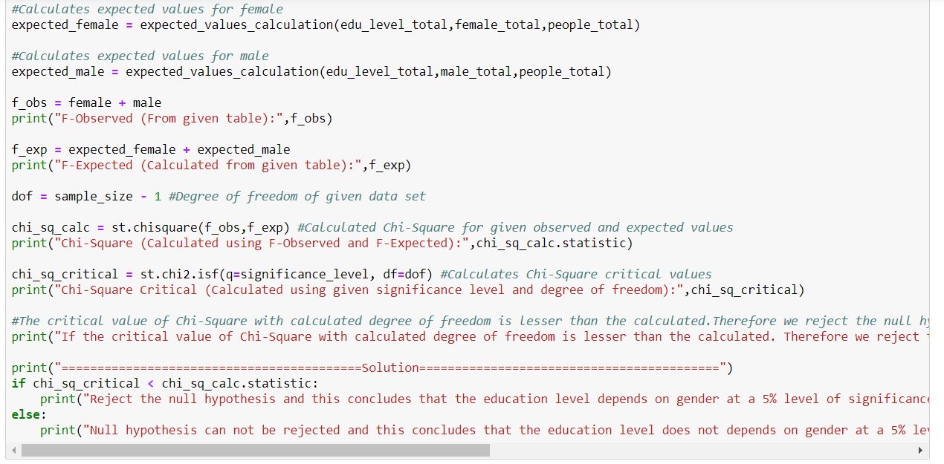

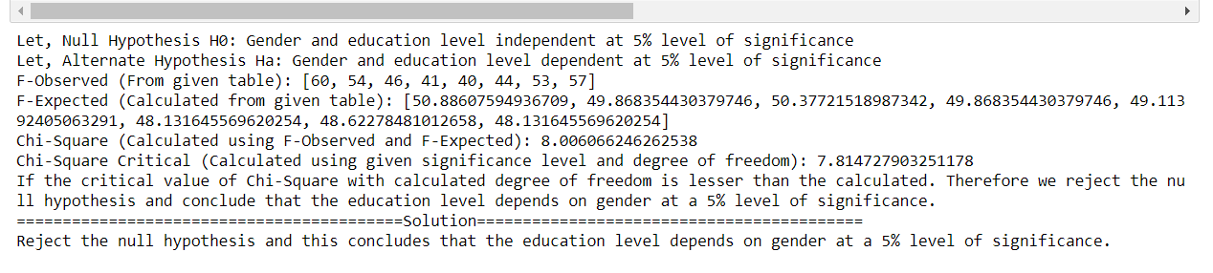

# Problem Statement 2:

2. Using the following data, perform a oneway analysis of variance using α=.05. Write up the

results in APA format.

[Group1: 51, 45, 33, 45, 67]

[Group2: 23, 43, 23, 43, 45]

# [Group3: 56, 76, 74, 87, 56]

## Solution

H0:μ1 =μ2 =μ3   
H1: Population means are not equal

Sum of squares between Treatments = Σ nj(X̄j - X̄)2

Sum of squares (Error) = ΣΣ (X - X̄j)2

Test-statistic = Σ nj(X̄j - X̄)2 / (k - 1) / ΣΣ (X - X̄j)2 / (N-k) where k = 3, N = 15

Source of Variation Sums of Squares Degrees of Freedom Mean Squares F between

Treatments: 3022.93 21511.47 9.75   
Error or Residual 1860.8 12 155.07

F0.5(2,12)=3.885

Since, 9.75>3.885, We Reject the null hypothesis.

Therefore, the population means are not equal.

In APA format, A one-way between subjects ANOVA was conducted to compare the effect of the group on values in group 1, group 2 and group 3. There was a signficant effect of group on values at α = 0.05 level for group 1, group 2, group 3.

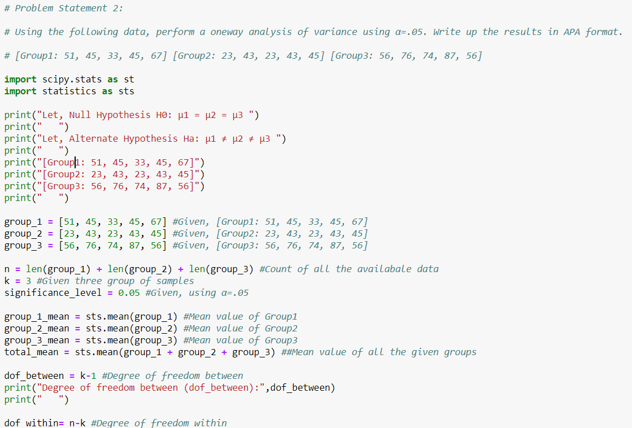

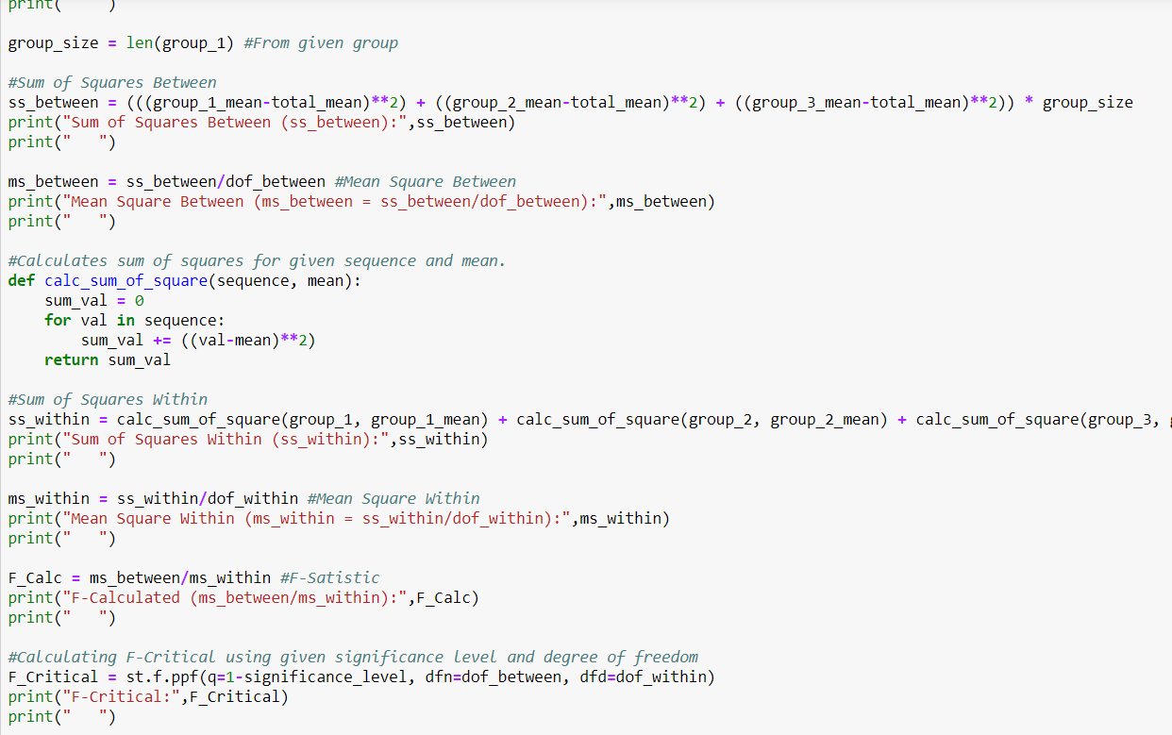

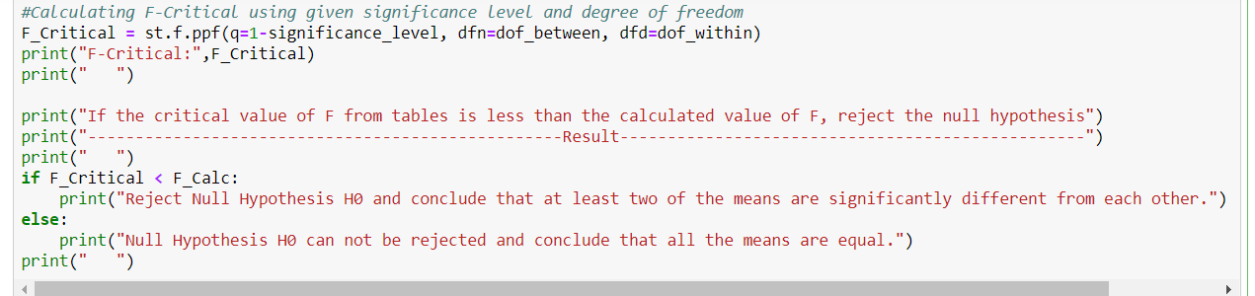

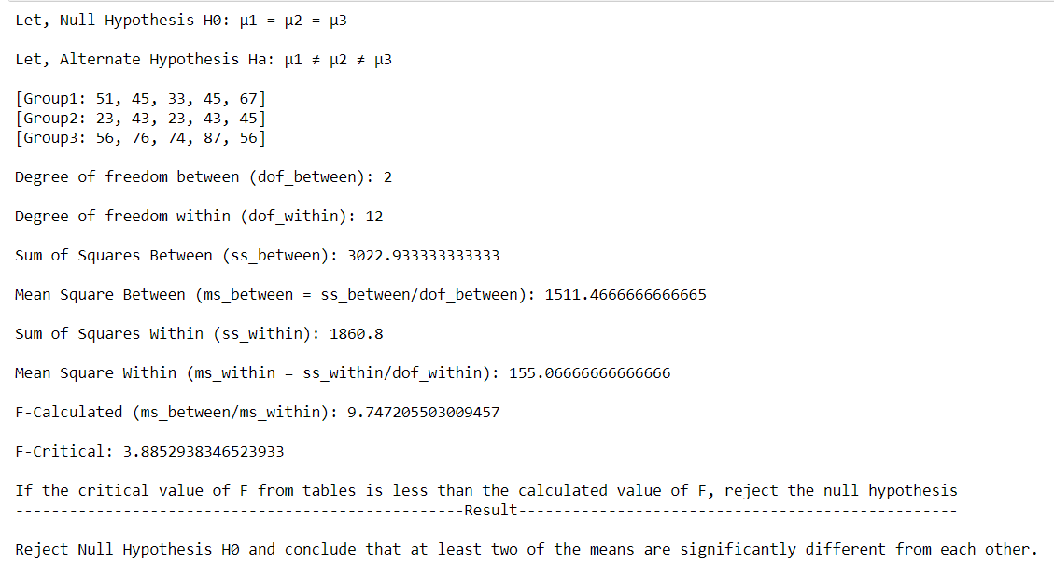

# Problem Statement 3:

Calculate F Test for given 10, 20, 30, 40, 50 and 5,10,15, 20, 25.

## Solution

Sample variance s2 = Σ(X - X̄)2/ N-1

s12 = (400.0 + 100.0 + 0.0 + 100.0 + 400.0)/4 = 250.0

s22 = (100.0 + 25.0 + 0.0 + 25.0 + 100.0)/4 = 62.5

F-statistic = s12/s22 = 250/62.5 = 4

